PARKING SPACES FOR PWD’S

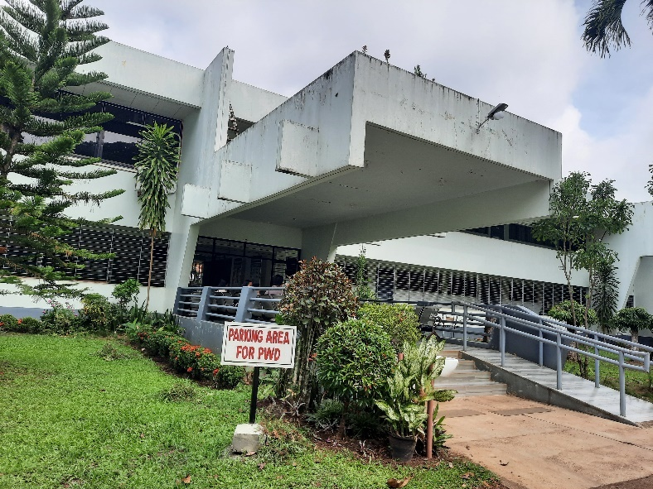 | 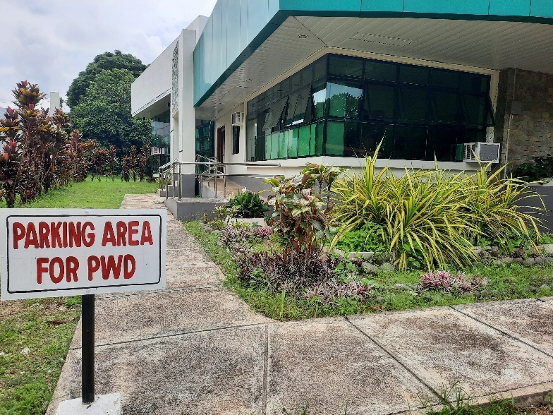
College of Veterinary Medicine | Gender and Development Building
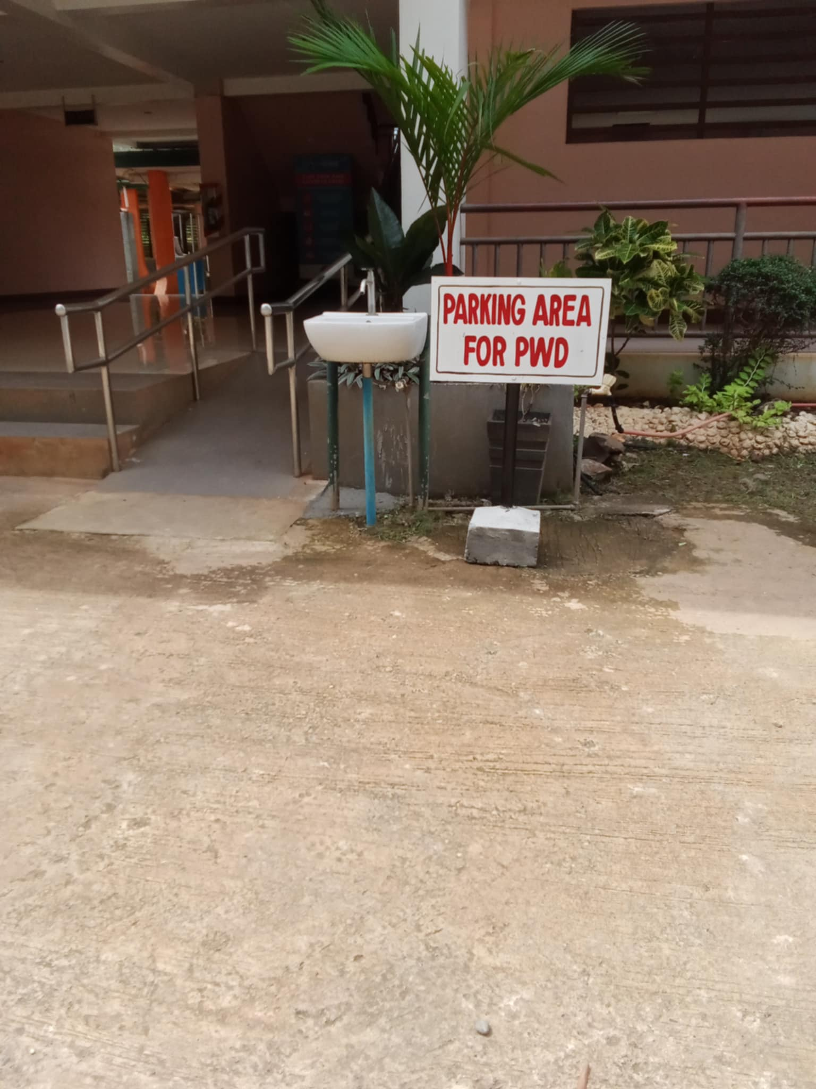 | 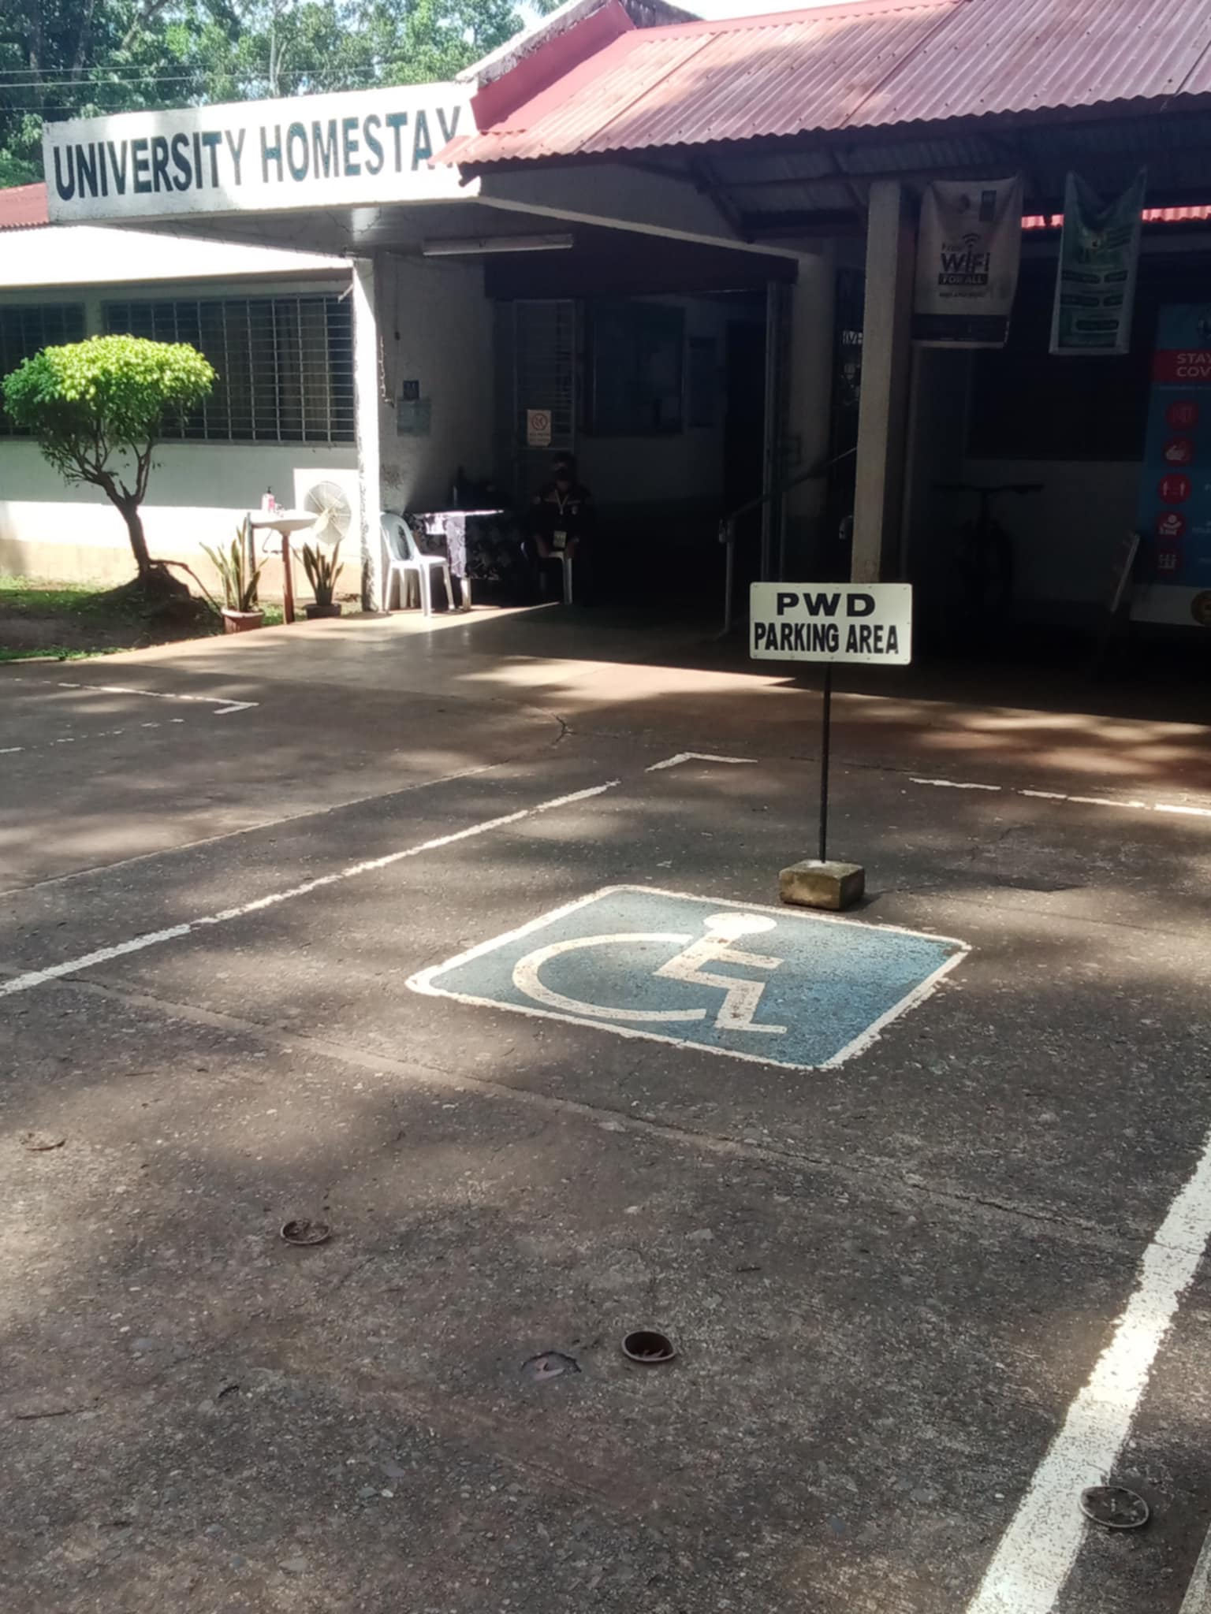
College of Business and Management | University Homestay

RAMPS FOR PWD’S

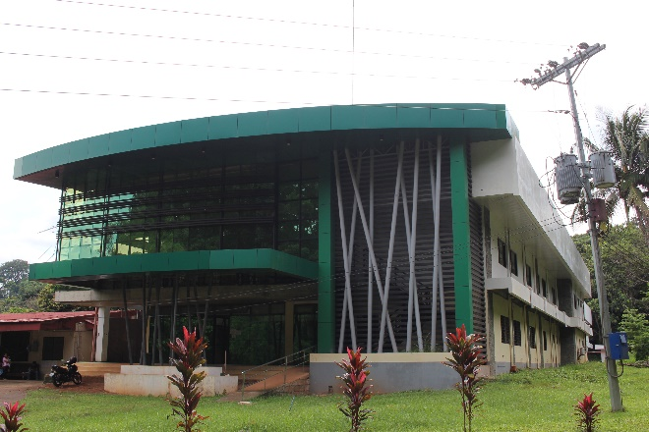 | 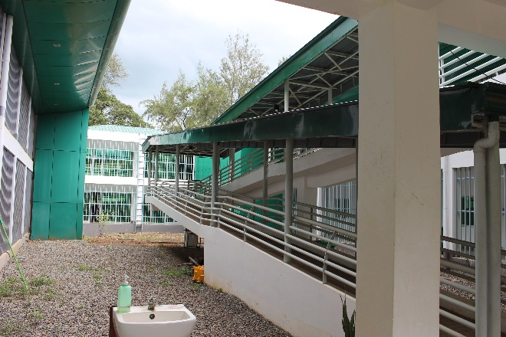
Front ramp. New University Hospital | Ramp. College of Information Science and Computing.
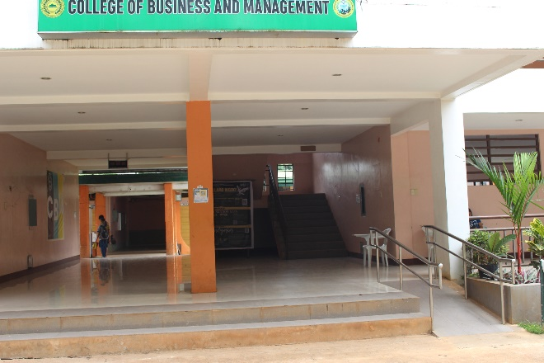 | 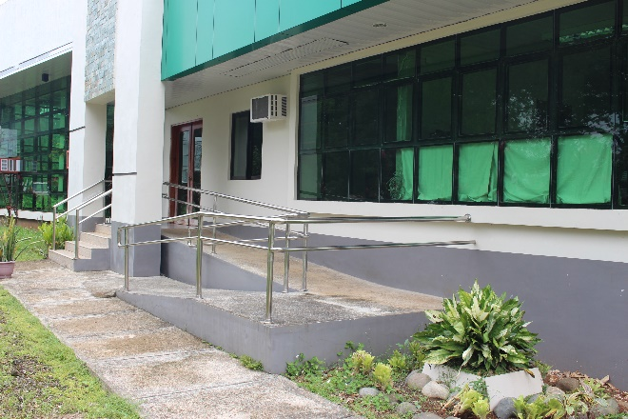
Front ramp. College of Business and Management. | Side ramp. Gender and Development.
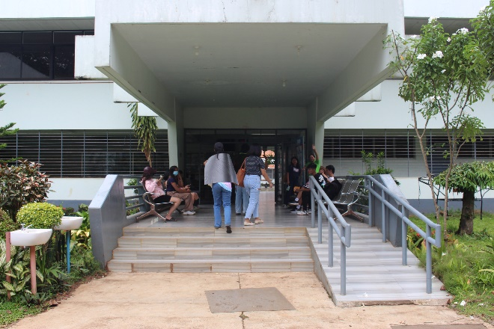 | 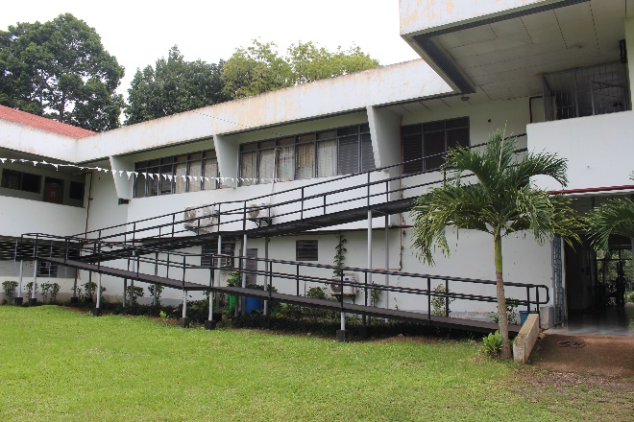
Front ramp. College of Veterinary Medicine. | Ramp to second floor. College of Veterinary Medicine.
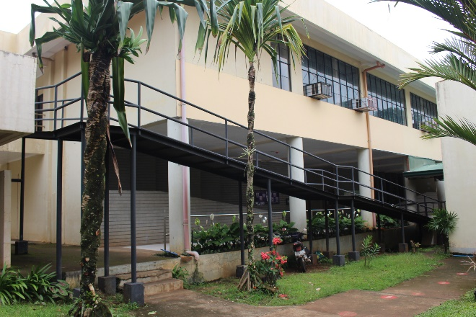 | 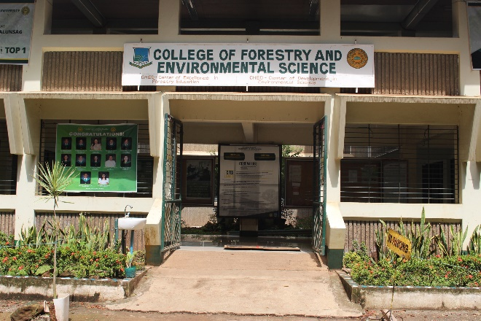
Ramp to second floor. College of Nursing. | Front ramp. College of Forestry and Environmental Science.
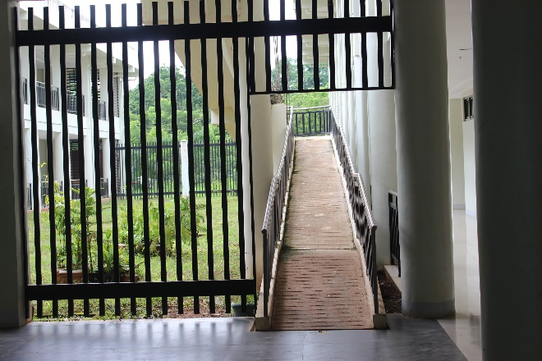 | 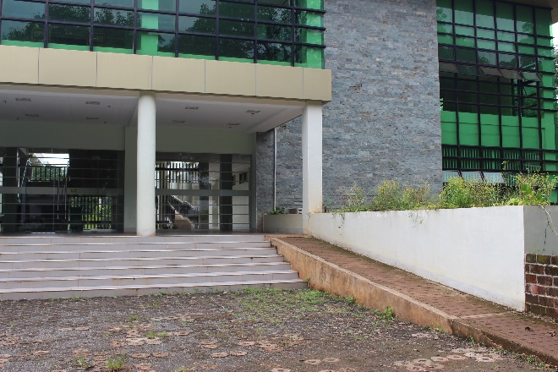
Ramp to second floor. K-12 Building. | Front ramp. K-12 Building.
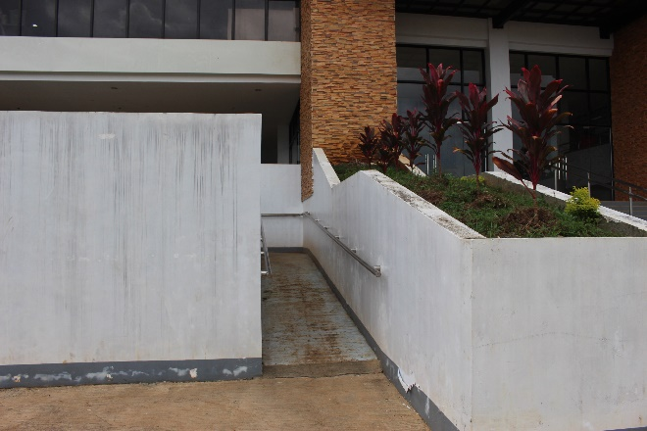 | 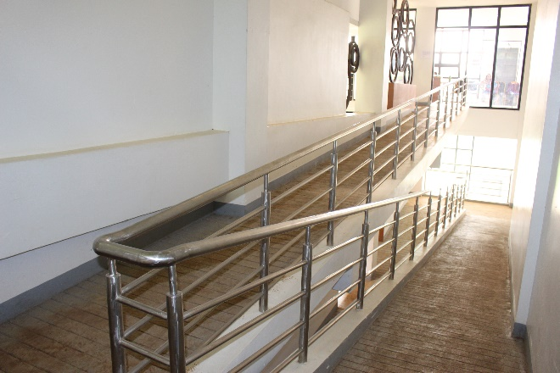
Front ramp. College of Human Ecology. | Ramp to 2nd and 3rd floor. College of Human Ecology.
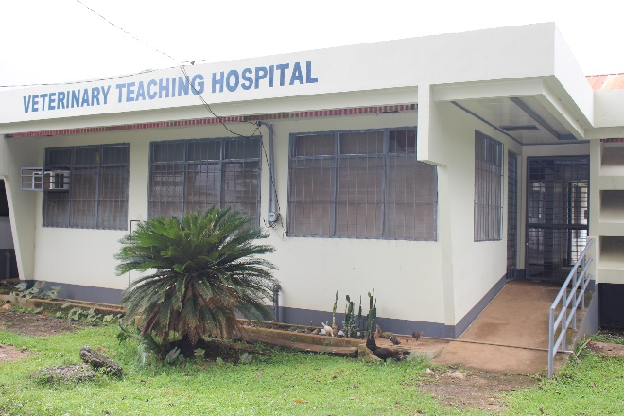 | 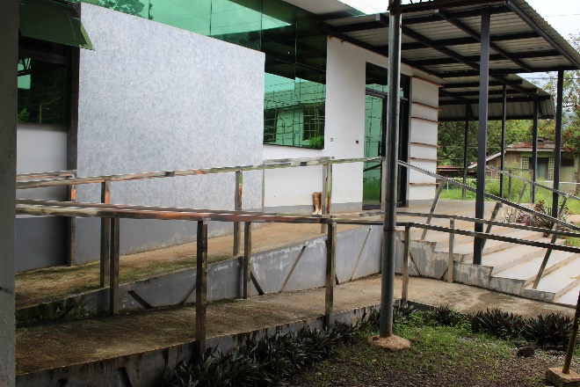
Back ramp. Veterinary Teaching Hospital. | Front ramp. Veterinary Teaching Hospital.
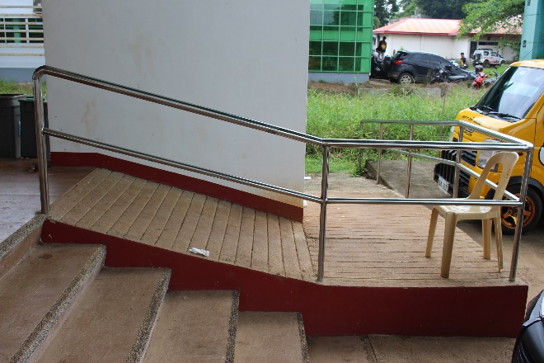 | 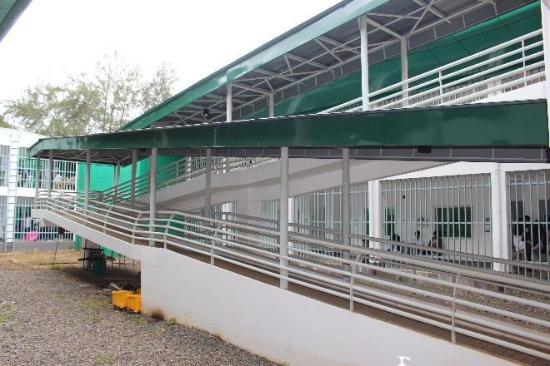
Ramp. Engineering Multipurpose Hall. | Ramp. College of Information Science and Computing.
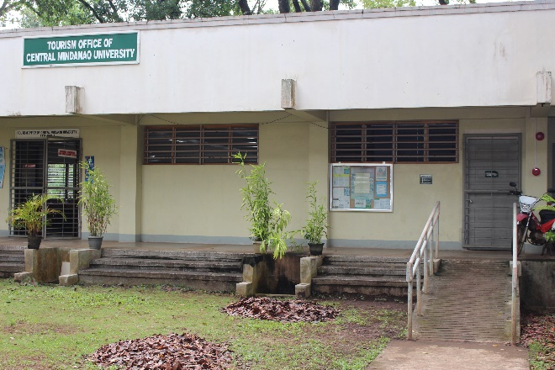 | 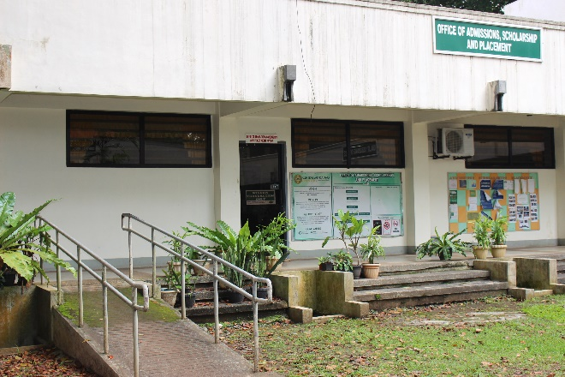
Ramp. Tourism Office. | Ramp. OASP.
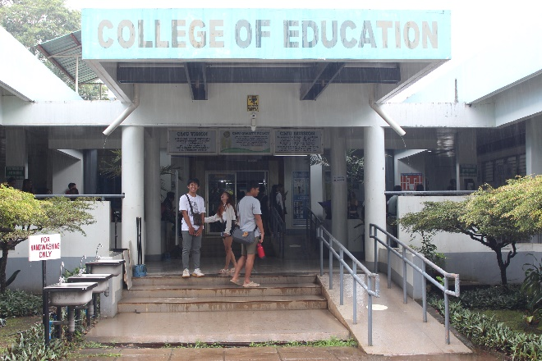 | 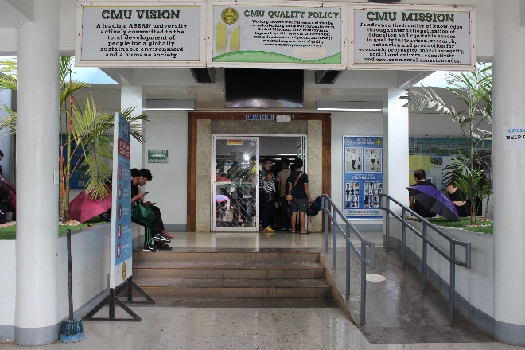
Outer ramp. College of Education. | Inner ramp. College of Education.
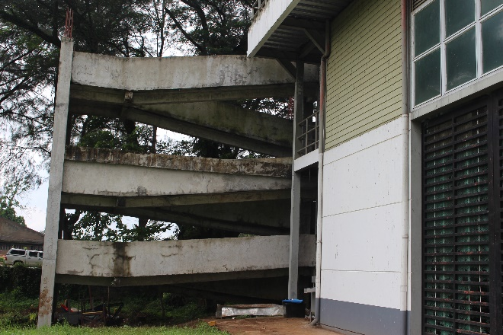 | 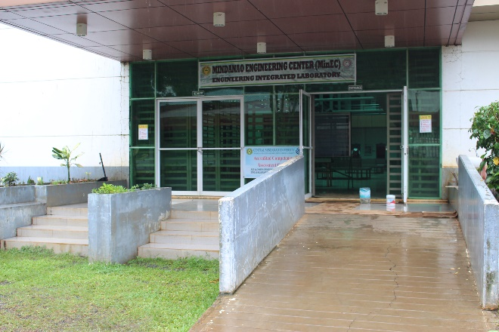
Ramp to 2nd and 3rd floor. Min Eng Center. | Front ramp. Mindanao Engineering Center.
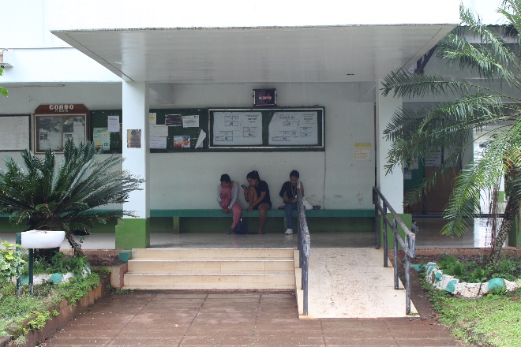 | 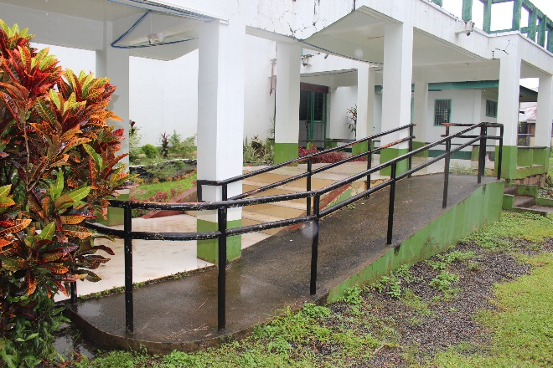
Front ramp. Cluster Building. | Side ramp. Cluster Building.
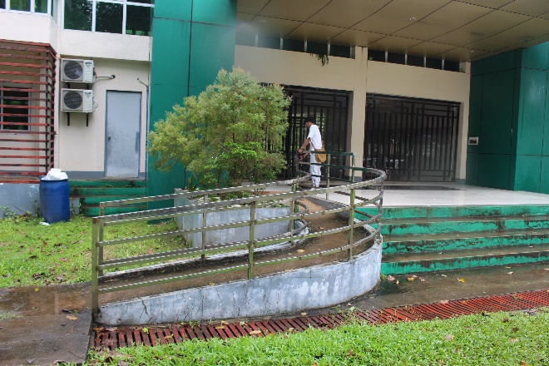 | 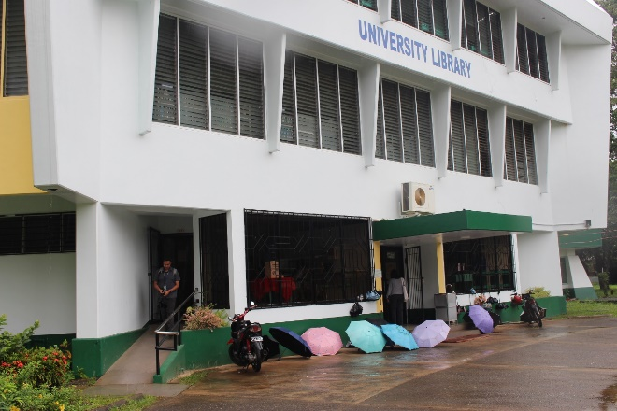
College of Agriculture Integrated Laboratory. | CMU Main Library
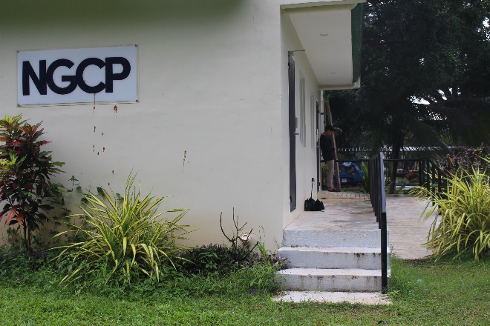 | 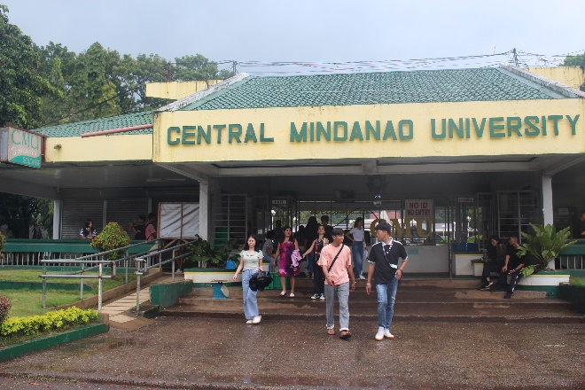
Ramp. NGCP Building. | Front ramp. CMU Main Gate.
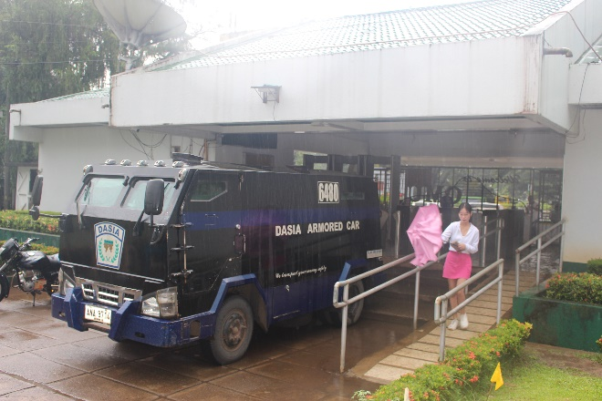 | 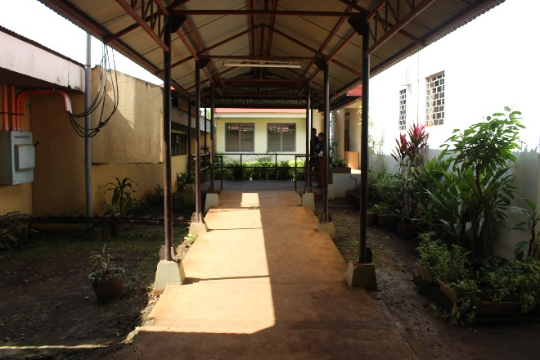
Back ramp. CMU Main Gate. | Side ramp. Farmers Training Center.
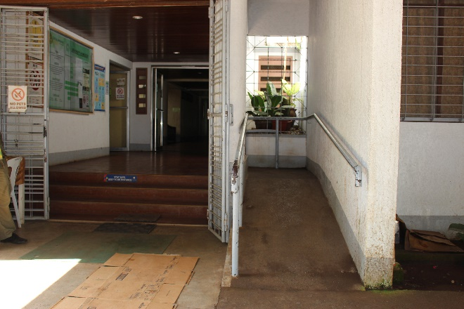 | 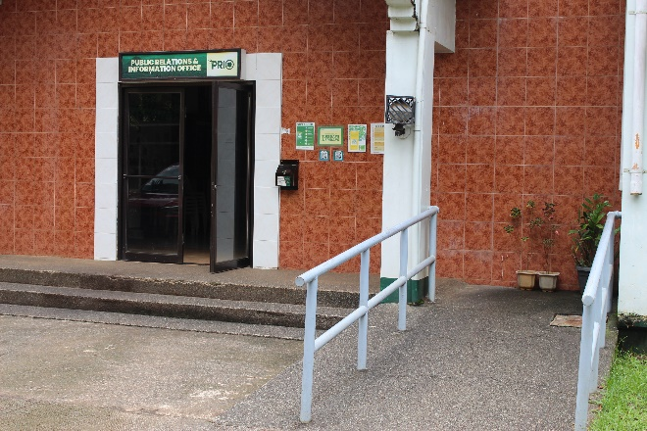
Front ramp. Homestay. | Public Relations and Information Office.
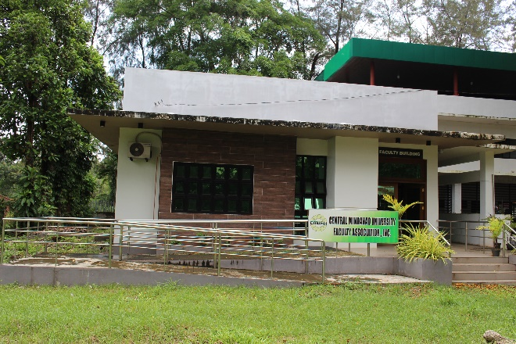 | 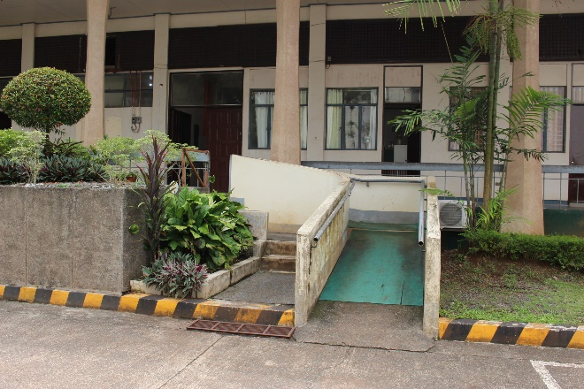
CMU Faculty Assoc. Inc. building. | Back ramp. CMU Administration bldg.
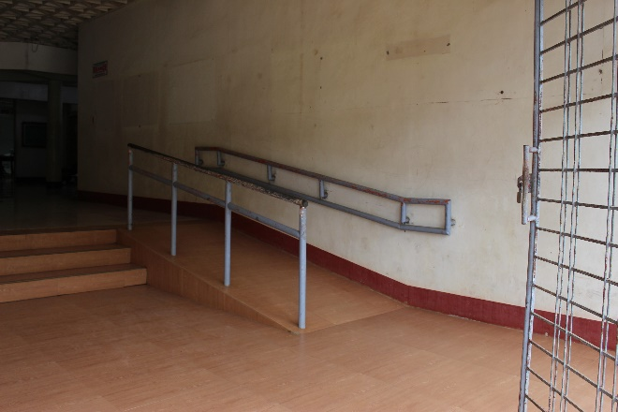 | 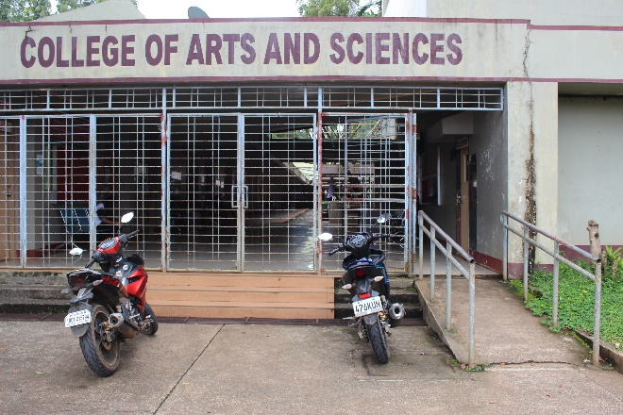
Front ramp. College of Arts and Sciences. | Back ramp. College of Arts and Sciences.

COMFORT ROOMS FOR PWD’S
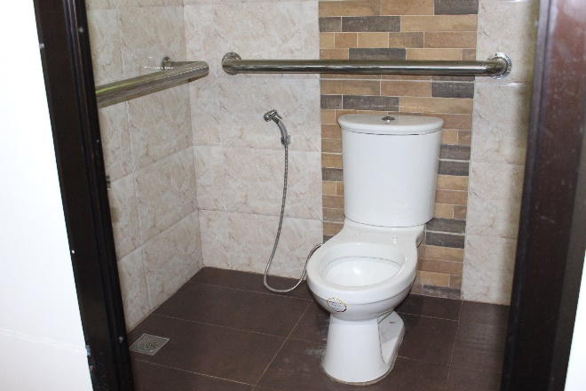 | 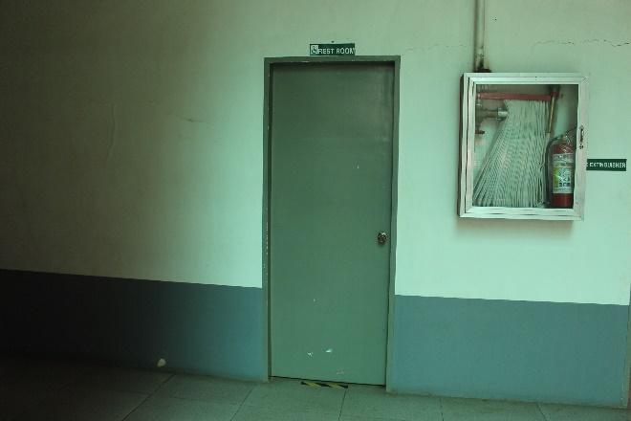
PWD Toilet. Gender and Development. | PWD Toilet. Min Engineering Center.

